

**COMSATS University Islamabad**

**Abbottabad, Pakistan**

**Wheel Magic**

***By***

**Bilal Tahir CIIT/SP21-BCS-045/ATD**

**Basit Ur Rehman CIIT/SP21-BSE-054/ATD**

**Irfan Gul CIIT/SP21-BSE-063/ATD**

***Supervisor*Sir Ahsan Riaz**

***Bachelor of Science in Software Engineering (2021-2025)***

**The candidate confirms that the work submitted is their own and appropriate  
 credit has been given where reference has been made to the work of others**.



**COMSATS University Islamabad**

**Abbottabad, Pakistan**

**Wheel Magic**

**A project presented to**

**COMSATS university Islamabad,**

**Abbottabad campus**

**In partial fulfillment**

**of the requirement for the degree of**

***Bachelor of Science in Software Engineering (2021-2025)***

**By**

**Bilal Tahir CIIT/SP21-BCS-045/ATD**

**Basit Ur Rehman CIIT/SP21-BSE-054/ATD**

**Irfan Gul CIIT/SP21-BSE-063/ATD**

**DECLARATION**

We hereby declare that this software, neither whole nor as a part has been copied out from any source. It is further declared that we have developed this software and accompanied report entirely on the basis of our personal efforts. If any part of this project is proved to be copied out from any source or found to be reproduction of some other. We will stand by the consequences. No Portion of the work presented has been submitted of any application for any other degree or qualification of this or any other university or institute of learning.

Basit Ur Rehman Malik Irfan Gul Bilal Tahir

--------------------------- --------------------------- ---------------------------

**CERTIFICATE OF APPROVAL**

It is to certify that the final year project of BS (CS) “Project title” was developed by   
**IRFAN GUL (CIIT/SP21-BSE/063)**, **Bilal Tahir (CIIT/Sp21-BCS/045) and Basit ur Rehman Malik (CIIT/SP21-BSE/054)(** under the supervision of “Sir Ahsan Riaz” and that in his opinion; it is fully adequate, in scope and quality for the degree of Bachelors of Science in Software Engineerings.

---------------------------------------

**Supervisor**

---------------------------------------

**External Examiner**

---------------------------------------

**Head of Department**

**(Department of Software Engineering)**

**EXECUTIVE SUMMARY**

The **Wheel Magic App** project is aimed at providing a platform for motorcycle and car owners to easily find genuine spare parts and accessories. Through advanced search filters, and secure transactions, the app streamlines the process of purchasing and selling vehicle parts. The development followed an agile methodology with tools such as **Node js** for the backend, **React Native** for the frontend, and **Firebase** for authentication and **MongoDB** for data management. This report covers the project’s objectives, methodology, and literature analysis, emphasizing how the project aligns with various academic modules studied in the Bachelor of software engineering (BSE) program.

**ACKNOWLEDGEMENT**

All praise is to Almighty Allah who bestowed upon us a minute portion of His boundless knowledge by virtue of which we were able to accomplish this challenging task.

We are greatly indebted to our project supervisor “Sir Ahsan Riaz”. Without their personal supervision, advice and valuable guidance, completion of this project would have been doubtful. We are deeply indebted to them for their encouragement and continual help during this work.

And we are also thankful to our parents and family who have been a constant source of encouragement for us and brought us the values of honesty & hard work.

Basit Ur Rehman Malik Irfan Gul Bilal Tahir

--------------------------- --------------------------- ---------------------------

**ABBREVIATIONS**

|  |  |
| --- | --- |
| **UC** | Use case |
| **PC** | Personal Computer |
| **SRS** | Software requirement specification |
| **DB** | Database |
| **TC** | Test cases |
| **API** | Application Programming Interface |

Contents

1. Introduction 11

1.1. Brief 11

1.2. Relevance to Course Modules 11

1.3. Project Background 11

1.4. Literature Review 11

1.5. Analysis from Literature Review 12

1.6. Methodology and Software Lifecycle for This Project 12

1.6.1. Rationale behind Selected Methodology 12

2.1. Problem Statement 13

2.2. Deliverable and Development Requirements 13

2.2.2.1. Technical Requirements 14

2.2.2.2. Business & Operational Requirements 15

3. Requirement Analysis 16

3.1. Use Cases Diagram(s) 16

3.2. Detailed Use Case 17

3.3. Functional Requirements 20

3.3.1. User Registration and Authentication 20

3.4. Non-Functional Requirements 21

4. Design and Architecture 22

4.1. System Architecture 22

4.2. Data Representation 22

4.3. Design Model 25

4.3.1. System Sequence Diagram 25

5. Implementation 34

5.1. Algorithm 34

Algorithm for wheel magic app is given below. 34

5.2. External APIs 35

5.3. User Interface 35

6. Testing and Evaluation 48

6.1. Manual Testing 48

6.1.1. System testing 48

6.1.2. Unit Testing 48

6.1.3. Functional Testing 49

6.1.4. Integration Testing 49

7. Conclusion and Future Work 53

7.1. Conclusion 53

7.2. Future Work 53

8. References 54

**LIST OF FIGURES**

*Fig 5. 1 Splash Screen 1* 37

*Fig 5. 2 Splash Screen 2* 38

*Fig 5. 3 Splash Screen 3* 39

*Fig 5. 4 Register Account* 40

*Fig 5. 5 Notifications* 41

*Fig 5. 6 Wishlist* 42

*Fig 5. 7 create listing* 43

*Fig 5. 8 Listings* 44

*Fig 5. 9 Marketplace* 45

*Fig 5. 10 Reviews* 46

*Fig 5. 11 Checkout 1* 47

*Fig 5. 12 Checkout 2* 48

**LIST OF TABLES**

*table 6.1.4. 1. Marketplace and payment system integration* 64

*table 6.1.4. 2 Wishlist and Notification System* 64

*table 6.1.4. 3 Payment system and notification system* 64

*table 6.1.4. 4 Notification and customer live support integration* 65

*table 6.1.4. 5 Review and feedback with marketplace integration* 65

1. **Introduction**

This chapter offers a comprehensive overview of the "Wheel Magic" project, encapsulating the essence and scope of the research undertaken. It sets the stage for the detailed exploration of the project's objectives, methodologies, technological framework, and the significant findings presented throughout this report.

* 1. **Brief**

The Wheel Magic App is designed to simplify the process of finding genuine spare parts and accessories for motorcycle and car owners. The key outcome is a user-friendly app that offers a wide catalogue and secure transactions. Tools like Visual Studio Code, Node js, and React Native were utilized in conjunction with firebase for authentication and MongoDB for data management. The project adopted an agile methodology to ensure continuous improvement through regular user feedback. The report discusses the app’s objectives, its relevance to software engineering principles, and detailed analysis through literature review.

* 1. **Relevance to Course Modules**

The project is closely linked to several modules covered during the BSE degree:

The app’s development process, including requirement gathering, system design, and implementation, aligns with software engineering principles taught in this course.

Tools like React Native were utilized to develop a mobile application, making use of knowledge gained from these modules.

Database Management Systems: The integration of firebase for authentication and MongoDB for data management reflects database concepts studied during BSE.

Designing a user-friendly interface aligns with HCI principles, focusing on the app’s usability and user experience.

* 1. **Project Background**

The idea behind the Wheel Magic App originated from the challenges faced by motorcycle and car owners when searching for genuine spare parts. The lack of a unified platform offering both new and used parts inspired the creation of this app. The app solves the issue of limited availability and poor search experiences, providing users with advanced filters and personalized suggestions. By integrating a marketplace feature, the app also enables users to buy and sell used parts, broadening its appeal.

* 1. **Literature Review**

Current trends in the automotive e-commerce sector reveal a growing demand for online platforms that provide authentic parts with fast delivery. The concept of marketplaces for used products is gaining traction in automotive platforms. Additionally, studies in secure payment gateways stress the need for strong encryption and fast, reliable transactions to boost user confidence.

* 1. **Analysis from Literature Review**

When compared to existing solutions like Auto Spare Connect and Pak Wheels, Wheel Magic distinguishes itself by offering a seamless user experience with a marketplace for used parts. While other platforms struggle with slow processing and overwhelming user interfaces, Wheel Magic simplifies navigation and enhances usability, especially for new users. Moreover, by offering both new and used parts, the app fills a gap in the market that other platforms have not fully addressed.

* 1. **Methodology and Software Lifecycle for This Project**

The agile methodology was selected for this project to ensure flexibility and adaptability throughout the development process. Agile focuses on iterative development, where features are broken down into small, manageable tasks and frequent testing is performed to gather user feedback. This feedback loop allows the team to make continuous improvements, ensuring that the app meets user needs effectively.

1. 6. 1. **Rationale behind Selected Methodology**

The rationale behind selecting the Agile methodology is its ability to handle evolving requirements and incorporate feedback quickly. Given that this app requires constant adjustments based on user preferences and market needs, Agile is the best fit for this project.

1. **Problem Definition**

This chapter defines the problem addressed by the Wheel Magic App project and presents the solution outcomes. The project focuses on solving the difficulty vehicle owners face in sourcing genuine spare parts and accessories.

4. 1. **Problem Statement**

Motorcycle and car owners often encounter significant challenges when searching for genuine and high-quality spare parts. The automotive spare parts industry is plagued by counterfeit products, inconsistent availability, and a lack of reliable sellers. Vehicle owners frequently resort to manual searches through multiple local shops, often leading to overpriced or substandard parts.

Existing online marketplaces and e-commerce platforms lack effective search mechanisms tailored for automotive parts, leading to inefficiencies in identifying the right components. Additionally, these platforms often fail to provide secure payment solutions and real-time inventory updates, resulting in order cancellations, delayed deliveries, and customer dissatisfaction.

Moreover, there is no centralized platform specifically designed for both individual buyers and sellers of new and used spare parts. Sellers struggle with limited visibility, while buyers face difficulty in verifying product authenticity. This results in a fragmented, time-consuming, and often frustrating buying experience.

The Wheel Magic App aims to address these issues by offering a comprehensive, secure, and user-friendly marketplace where vehicle owners can efficiently find, compare, and purchase genuine spare parts. The platform integrates advanced search capabilities, real-time inventory updates, and secure payment gateways to enhance user experience and streamline the purchasing process.

* 1. **Deliverable and Development Requirements**

The Wheel Magic App project is designed to develop a scalable and reliable solution that meets the needs of vehicle owners, part sellers, and automotive service providers. The key deliverables and technical requirements are outlined below:

**2.2.1 Key Deliverables**

The project aims to deliver a fully functional mobile application developed using React Native, ensuring seamless deployment on both Android and iOS platforms. The application will feature an intuitive UI/UX design to enhance user engagement and accessibility.

A comprehensive marketplace functionality will be integrated, allowing users to browse, compare, and purchase both new and used spare parts. Sellers will have the ability to create listings, including product descriptions, images, and pricing, ensuring a dynamic and competitive marketplace.

To facilitate secure transactions, the platform will implement paymentgateways such as Stripe, ensuring seamless and secure order processing. Additionally, users will benefit from real-time order tracking and automated invoice generation, enhancing transparency and reliability in transactions.

A robust user management system will be established, incorporating secure registration, authentication, and profile management for both buyers and sellers. The system will also implement role-based access control, ensuring appropriate permissions for buyers, sellers, and administrators.

For efficient data handling, the platform will utilize a real-time database such as Firebase or an equivalent solution, enabling seamless data synchronization. Cloud storage will be employed for managing product images and transaction records, ensuring scalability and security.

To enhance customer support and community engagement, the application will feature a live chat system for real-time assistance. Additionally, a community forum will be introduced, allowing buyers and sellers to interact, exchange knowledge, and share reviews, fostering a collaborative user experience.

**2.2.2 Development Requirements**

To successfully implement the Wheel Magic App, the following technical and business requirements must be met:

### 2.2.2.1. Technical Requirements

The frontend development will be carried out using React Native, enabling cross-platform compatibility for both Android and iOS devices. The backend will be built using Node.js with Express.js, ensuring efficient API handling and server-side logic. For data storage, the application will utilize Firebase or MongoDB, providing real-time updates and seamless synchronization. Additionally, Stripe will be integrated to facilitate secure payment transactions, ensuring a reliable checkout experience for users. The application will be deployed using a cloud-based infrastructure with Firebase, ensuring scalability, high availability, and seamless performance across multiple regions.

To safeguard user data and transactions, the platform will implement OAuth 2.0 and JWT authentication, ensuring secure logins and user access management. Additionally, end-to-end encryption will be applied to protect sensitive data, maintaining confidentiality and integrity throughout the application. A structured testing approach will be followed to ensure the stability and reliability of the application. Unit testing will be conducted to validate individual components, while functional testing will verify the overall behaviour of the application. Furthermore, integration testing will be carried out to ensure seamless interaction between different modules, reducing the likelihood of system failures.

### 2.2.2.2. Business & Operational Requirements

The project will comply with legal and regulatory requirements by obtaining business registration and licensing for online marketplace operations. Additionally, it will adhere to e-commerce regulations and consumer protection laws, ensuring a compliant and trustworthy platform for buyers and sellers. To drive marketing and user acquisition, the platform will leverage social media campaigns, influencer partnerships, and targeted advertisements to increase visibility and engagement. Moreover, referral programs and loyalty rewards will be introduced to encourage user participation and long-term retention.

For scalability and future expansion, the platform will extend its services to international markets, incorporating multi-currency support to accommodate global transactions. Additionally, subscription plans for premium sellers will be introduced, providing exclusive benefits and enhanced visibility. Looking ahead, potential integration with automobile service providers will be explored, offering users access to maintenance and repair services within the platform.

1. **Requirement Analysis**

This chapter outlines the software requirements for wheel magic app.

4. 1. **Use Cases Diagram(s)**

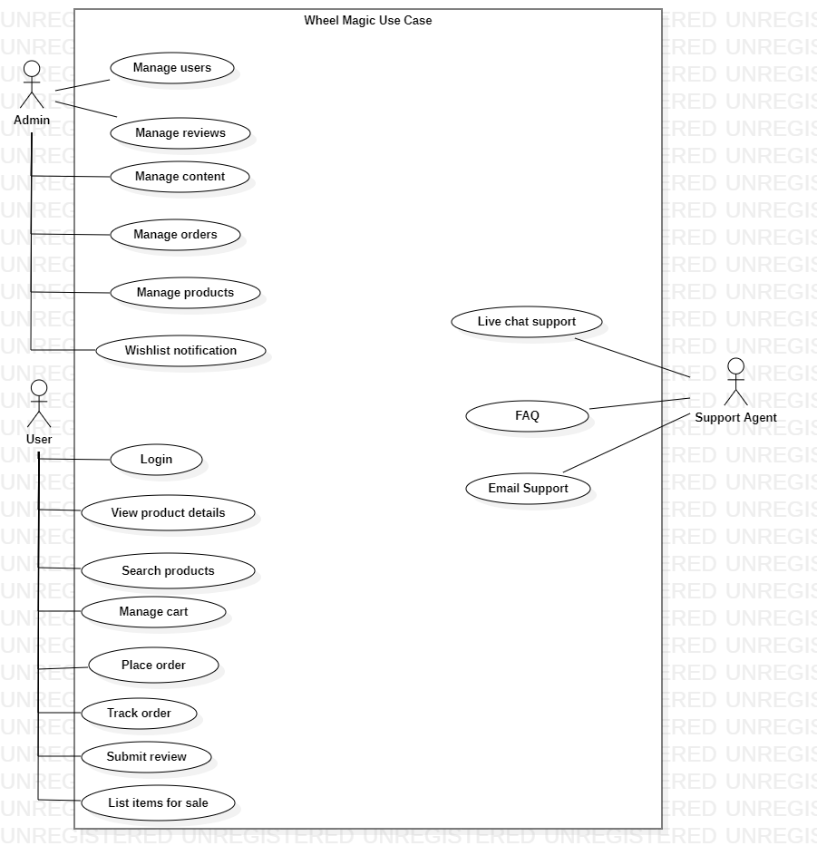

*Fig 3. 1 Use Case Diagram*

The primary actor in the system is the user, who interacts with various functionalities such as managing accounts, orders, and reviews. The support system serves as a supporting actor, responsible for handling user support operations, including live chat, FAQs, and email assistance.

User management involves adding, updating, and deleting user profiles to ensure proper account handling. Content management includes the ability to add, edit, and delete product reviews, as well as updating or curating system-wide content such as product descriptions. Order and product management covers tracking, updating, and processing customer orders, along with adding or modifying product details and managing inventory. Notifications play a crucial role in keeping users informed, such as sending alerts about changes or availability of items in their wishlist.

For user interaction with products, users can log in to access the platform, view product details, search for products based on specific criteria, and manage their shopping cart by adding or removing items. The order workflow encompasses placing orders through the checkout process and tracking them in real time to monitor status and delivery updates. Users can also provide feedback by submitting reviews for purchased products and listing items for sale on the platform.

Support services ensure user queries are addressed efficiently through live chat support, providing real-time assistance, while FAQs offer predefined answers to commonly asked questions. Additionally, email support enables users to reach out for more in-depth inquiries. The relationships between actors and use cases are defined through associations, where users and the support system interact with various functionalities through connecting processes within the system.

* 1. **Detailed Use Case**

*Table 3. 1 UC-1*

|  |  |
| --- | --- |
| **Use Case ID:** | **UC-1** |
| Use Case Name: | Register User |
| Actors: | Primary Actor: User |
| Description: | A user creates a new account on the Wheel Magic app by providing necessary information and verifying their email address. |
| Trigger: | A user chooses to register a new account. |
| Preconditions: | The user has not registered before. |
| Postconditions: | A new user account is created and activated. |
| Normal Flow: | 1. User opens the Wheel Magic app and navigates to the registration page. 2. User enters required information: username, password, email address. 3. System validates the entered information. 4. System sends a confirmation email to the user's email address. 5. User opens the email and clicks on the confirmation link. 6. System activates the user account. 7. User receives a confirmation message. |
| Alternative Flows: | Invalid Information**:** 1. System detects invalid information during step 3. 2. System displays an error message. 3. User corrects the information and resubmits. EmailNot Sent**:** 1. System fails to send the confirmation email during step 4. 2. System logs an error and prompts the user to retry or contact support. |
| Exceptions: | |  | | --- | |  |  |  | | --- | | None | |
| Business Rules | |  | | --- | |  |  |  | | --- | | None | |
| Assumptions: | User has access to the internet and a valid email address. |

*Table 3. 2 UC-2*

|  |  |
| --- | --- |
| **Use Case ID:** | **UC-2** |
| Use Case Name: | Search for Products |
| Actors: | Primary Actor: User |
| Description: | A user searches for automotive parts on the Wheel Magic app using keywords or filters. |
| Trigger: | A user initiates a search using the search bar. |
| Preconditions: | User is logged into the Wheel Magic app. |
| Postconditions: | Search results are displayed to the user. |
| Normal Flow: | 1. User logs into the Wheel Magic app. 2. User navigates to the search bar. 3. User enters keywords or filters. 4. System retrieves and displays matching products. 5. User browses the search results and selects a product. |
| Alternative Flows: | No Matching Products**:** 1. System detects no products matching the search criteria during step 4. 2. System displays a "no results found" message and suggests alternative search options. |
| Exceptions: | |  | | --- | |  |  |  | | --- | | None | |
| Business Rules | |  | | --- | |  |  |  | | --- | | None | |
| Assumptions: | User knows the keywords or filters relevant to their search. |

*Table 3. 3 UC-3*

|  |  |
| --- | --- |
| **Use Case ID:** | **UC-3** |
| Use Case Name: | Place an Order |
| Actors: | Primary Actor: User |
| Description: | A user places an order for selected automotive parts on the Wheel Magic app. |
| Trigger: | A user decides to purchase items in their shopping cart. |
| Preconditions: | PRE-1: User is logged into the Wheel Magic app. PRE-2: User has added items to the shopping cart. |
| Postconditions: | POST-1: Order is confirmed and stored in the system. |
| Normal Flow: | 1. User logs into the Wheel Magic app. 2. User selects products and adds them to the cart. 3. User reviews the cart and proceeds to checkout. 4. User enters shipping and payment information. 5. System validates the information. 6. System processes the payment and confirms the order. 7. User receives an order confirmation message and email. |
| Alternative Flows: | Invalid Information: 1. System detects invalid information during step 5. 2. System displays an error message. 3. User corrects the information and resubmits. Payment Failure: 1. System fails to process the payment during step 6. 2. System displays an error message and prompts the user to retry or use a different payment method. |
| Exceptions: | |  | | --- | |  |  |  | | --- | | None | |
| Business Rules | |  | | --- | |  |  |  | | --- | | None | |
| Assumptions: | 1. User has valid payment and shipping information. |

*Table 3. 4 UC-4*

|  |  |
| --- | --- |
| **Use Case ID:** | **UC-4** |
| Use Case Name: | Manage Products |
| Actors: | Primary Actor: Admin |
| Description: | An admin adds, edits, or deletes products in the Wheel Magic app. |
| Trigger: | An admin chooses to manage product listings. |
| Preconditions: | Admin is logged into the Wheel Magic app. |
| Postconditions: | Product catalogue is updated. |
| Normal Flow: | 1. Admin logs into the Wheel Magic app. 2. Admin navigates to the product management section. 3. Admin selects the option to add, edit, or delete a product. 4. Admin enters or modifies product information. 5. System validates the information. 6. System updates the product catalogue. 7. Admin receives a confirmation message. |
| Alternative Flows: | Invalid Information:1. System detects invalid product information during step 5. 2. System displays an error message. 3. Admin corrects the information and resubmits. |
| Exceptions: | |  | | --- | |  |  |  | | --- | | None | |
| Business Rules | |  | | --- | |  |  |  | | --- | | None | |
| Assumptions: | Admin has the necessary permissions to manage products. |

*Table 3. 5 UC-5*

|  |  |
| --- | --- |
| **Use Case ID:** | **UC-5** |
| Use Case Name: | Submit Product Review |
| Actors: | Primary Actor: User |
| Description: | A user provides feedback on purchased products by submitting reviews. |
| Trigger: | A user decides to review a purchased product. |
| Preconditions: | User is logged into the Wheel Magic app. |
| Postconditions: | Review is stored and displayed on the product page. |
| Normal Flow: | 1. User logs into the Wheel Magic app. 2. User navigates to the product page of a purchased item. 3. User selects the option to submit a review. 4. User enters the review and rating. 5. System validates the review content. 6. System stores the review. 7. System displays the review on the product page. |
| Alternative Flows: | Inappropriate Review: 1. System detects inappropriate content during step 5. 2. System flags the review for moderation and notifies the user. |
| Exceptions: | |  | | --- | |  |  |  | | --- | | None | |
| Business Rules | |  | | --- | |  |  |  | | --- | | None | |
| Assumptions: | User has purchased the product they are reviewing. |

*Table 3. 6 UC-6*

|  |  |
| --- | --- |
| **Use Case ID:** | **UC-6** |
| Use Case Name: | Contact Support |
| Actors: | Primary Actor: User |
| Description: | A user contacts support to resolve issues or get help. |
| Trigger: | A user chooses to contact support. |
| Preconditions: | User is logged into the Wheel Magic app. |
| Postconditions: | Support request is logged and responded to. |
| Normal Flow: | 1. User logs into the Wheel Magic app. 2. User navigates to the support section. 3. User selects the preferred contact method (e.g., live chat, email). 4. User submits a support request. 5. System routes the request to the appropriate support agent. 6. Support agent responds to the user. 7. User and support agent resolve the issue. |
| Alternative Flows: | **Request Submission Failure:** 1. System fails to submit the support request during step 4. 2. System displays an error message and prompts the user to retry or use a different contact method. |
| Exceptions: | |  | | --- | |  |  |  | | --- | | None | |
| Business Rules | |  | | --- | |  |  |  | | --- | | None | |
| Assumptions: | User has a valid issue or query for support. |

* 1. **Functional Requirements**
     1. **User Registration and Authentication**

Users must be able to register, log in, and update their profiles securely.

* + 1. **Product Catalog Management**

The system should provide a comprehensive product catalog with filtering and sorting capabilities.

* + 1. **Order Management**

Users must be able to place, track, and manage orders.

* + 1. **Marketplace**

Users can buy and sell used parts.

* 1. **Non-Functional Requirements**
     1. **Performance**

The app must respond to search queries within 2 seconds.

* + 1. **Scalability**

The app should support a growing user base and expanding product catalog.

* + 1. **Security**

Ensure data encryption during transactions and user authentication.

* + 1. **Usability**

The app should offer an intuitive and user-friendly interface.

1. **Design and Architecture**

The following parts of Software Design Description (SDD) report should be included in this chapter.

8. 1. **System Architecture**

The architecture of the Wheel Magic App follows a modular design, enabling seamless integration of various modules, including user management, product catalog, order processing. The architecture is composed of the frontend (React Native), backend (Node js), and firebase for authentication and MongoDB for data management

* 1. **Data Representation**

Below is the activity diagram of the project.

* + 1. **Activity Diagram**

The activity diagram for the Wheel Magic App illustrates the workflow of the system, from user authentication to purchasing spare parts. It maps out key actions like user login, product search, order placement, secure payment processing, and order confirmation. The diagram highlights decision points, interactions between buyers and sellers, and the system’s response to user actions.

* + - 1. **User Activity diagram**

The User Activity Diagram for the Wheel Magic App visually represents the user's journey within the application. It starts from the Splash Screen, leading to the Login process, where users authenticate their credentials. If authentication is unsuccessful, an Error Message is displayed. Unregistered users can navigate to the Signup process, followed by Email Confirmation and Account Creation. Successfully logged-in users are directed to the Home Screen, where they can access different features like Marketplace, View Product, Order Product, and Profile. The diagram concludes with the user's actions within the system.

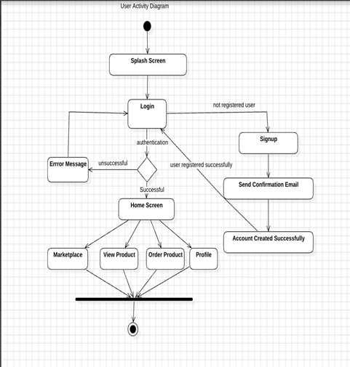

*Fig 4. 1 User Activity Diagram*

* + - 1. **Admin Activity Diagram**

The **Admin Activity Diagram** illustrates the flow of actions for an administrator in the **Wheel Magic App.** It begins with the **Splash Screen**, leading to the **Login Screen**, where the admin authenticates their credentials. If authentication fails, an **Error Message** is shown. Unregistered admins can proceed to the **SignUp** process, after which their **Account is Created Successfully**. Upon successful login, the admin accesses the **Admin Page**, where they can manage different functionalities, including **Manage Products, Manage Users**, and **Manage Reviews**. The diagram concludes after these actions are performed.

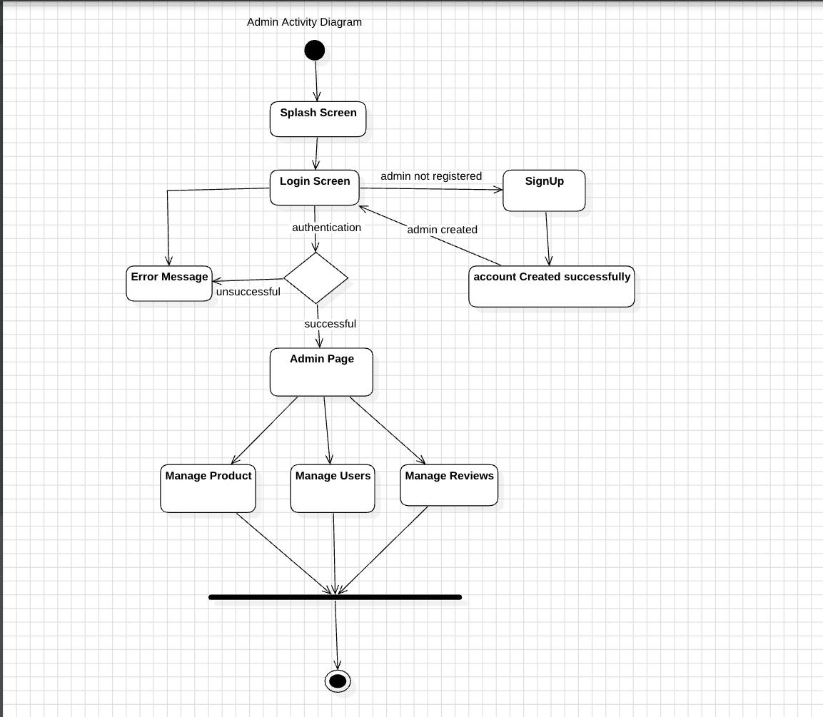

*Fig 4. 2 Admin Activity Diagram*

* + - 1. **Support Centre Activity Diagram**

The process begins with the user encountering the Splash Screen. If the user is already registered, they proceed to the Login Screen. Successful authentication (entering correct credentials) grants access to the Support Page.Unsuccessful authentication results in an Error Message. If the user is not registered, they are directed to the Signup screen. Upon successful registration, a message "account Created successfully" is displayed. From the support page, the user can access various options, FAQ, email support, live chat support. The diagram concludes after these actions are performed.

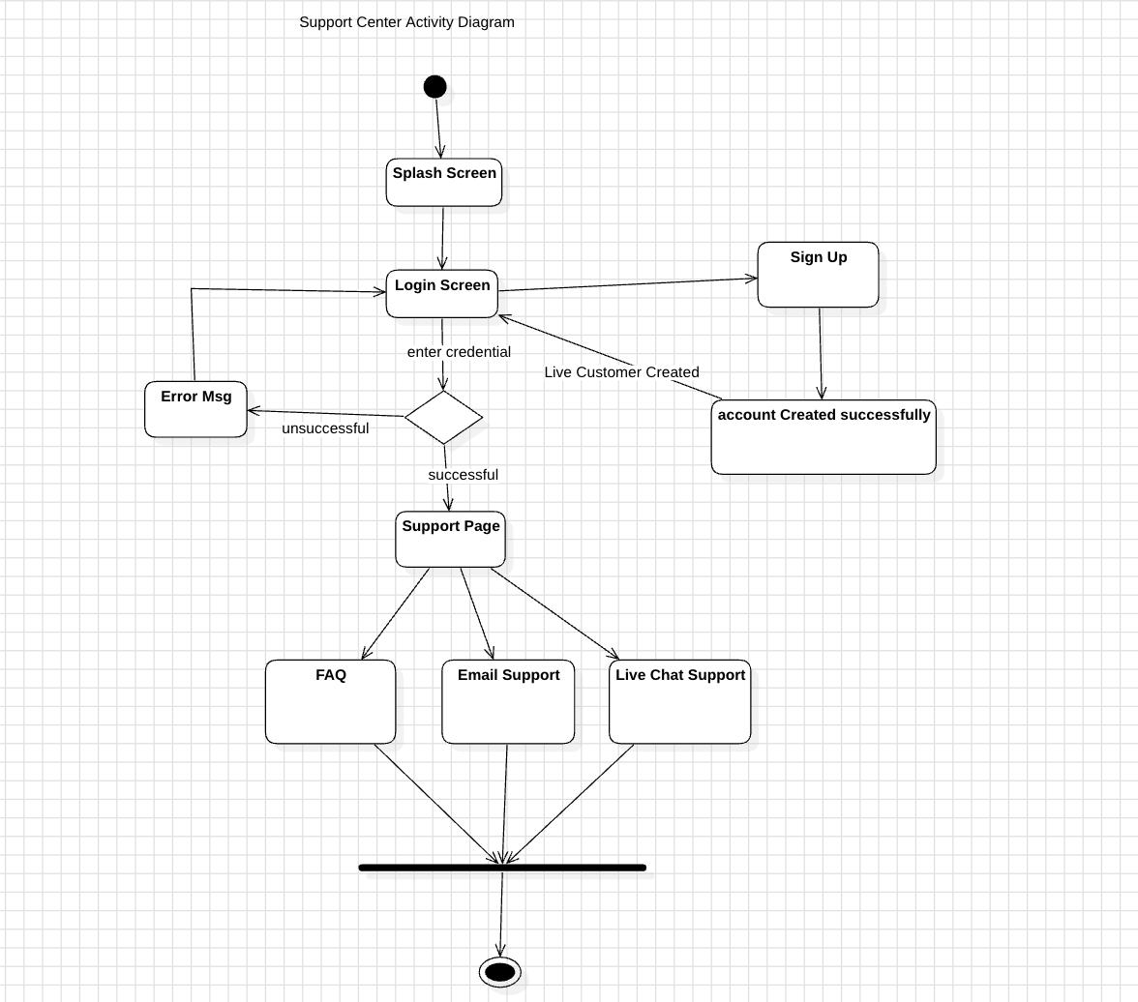

*Fig 4. 3 Support center Activity Diagram*

* 1. **Design Model**

Below are the design models of the Wheel magic app.

* + 1. **System Sequence Diagram**

This SSD captures key interactions for system modules such as login, product browsing, order tracking, and support services. It ensures clarity in defining the flow of operations and facilitates better communication between stakeholders and developers.

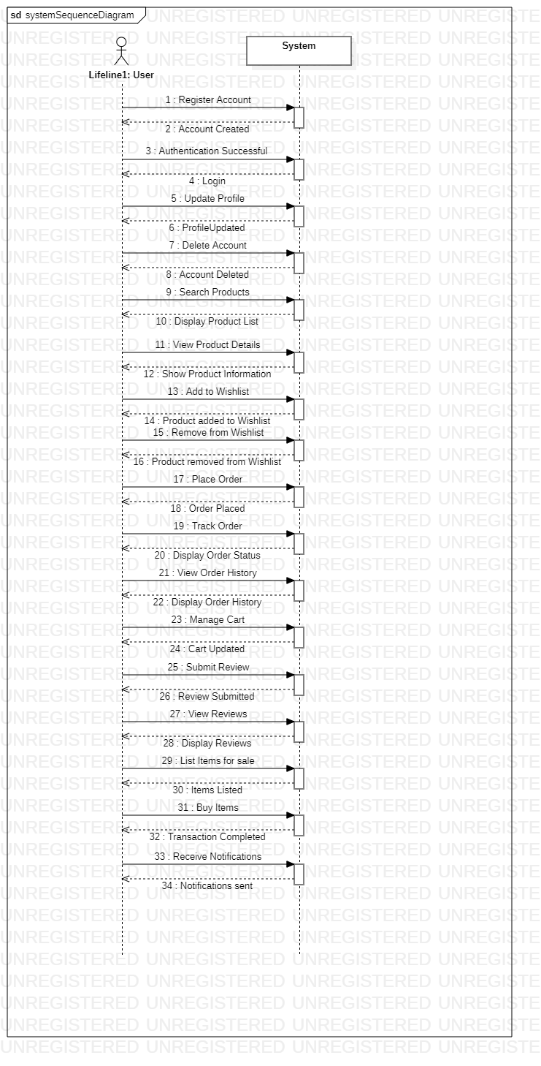

*Fig 4. 4 System Sequence Diagram*

**4.3.2. Sequence Diagram**

This sequence diagram provides a visual representation of the typical flow of events in an online shopping transaction, highlighting the interactions between the user, the web application, and various backend systems.

The user browses the web application and selects items to purchase, adding them to their shopping cart. Once the user is ready to purchase, they navigate to the checkout page. The web application initiates a payment request to the Payment Gateway. The Payment Gateway processes the payment information and verifies its validity. Upon successful payment verification, the web application submits the order details to the Order Processing system. The Order Processing system updates the inventory levels to reflect the items purchased. The Order Processing system confirms the order and sends a notification back to the web application.

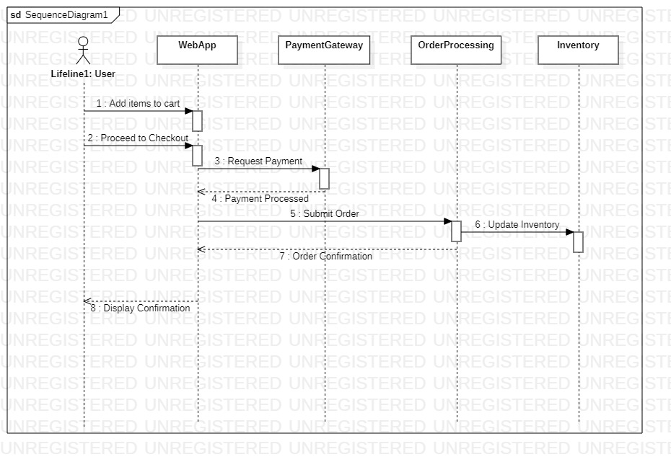

*Fig 4. 5 Sequence Diagram*

* + 1. **ER Diagram**

The **ERD (Entity-Relationship Diagram)** for the **Wheel Magic App** represents key database entities and their attributes. The **admin** entity stores administrator details, including id, name, and role. The **User** entity contains user-related information such as id, username, email, and password. The **Product** entity represents items listed on the platform, with attributes like id, name, description, and price. The **Order** entity tracks product purchases, including id, userId, productId, quantity, and status. The **Review** entity allows users to rate and comment on products, storing id, productId, userId, rating, and comment. The **Support** entity manages user queries with attributes id, userId, and issue, while the **Notification** entity stores notifications sent to users, containing id, userId, and message. Each entity has a **primary key (PK)** to uniquely identify records, while foreign keys such as userId and productId establish relationships between different tables, ensuring data consistency and integrity.

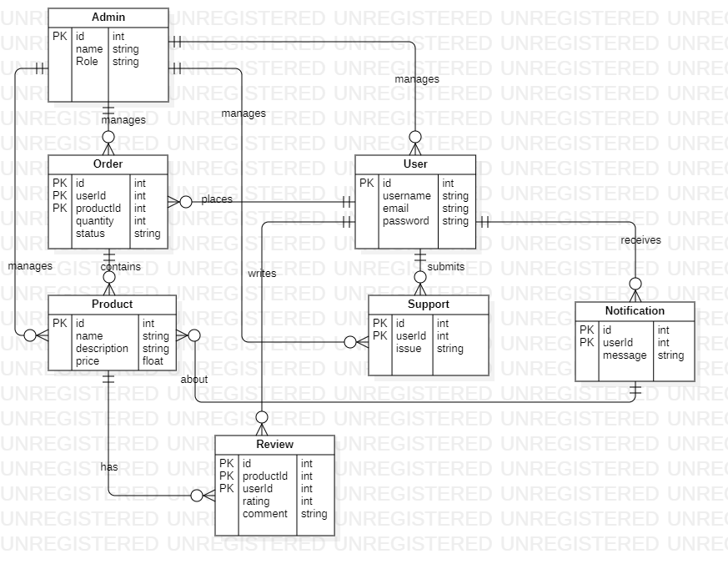

*Fig 4. 6 ER Diagram*

**4.4.3. Data Flow Diagram**

The 3 levels of DFD are given below.

**4.4.3.1. Level 0**

The **WheelMagic App** serves as the central process, representing the core functionality of the e-commerce platform. Various data stores are involved in maintaining essential information. The **User** data store holds registered users' personal details and order history, ensuring smooth transactions. The **Admin** data store manages administrative tasks, including product catalog updates and user management. The **FAQ** data store functions as a knowledge base, containing frequently asked questions and their answers to assist users. Several data flows ensure seamless interactions within the system. The **Place Order** data flow is initiated by users to process product purchases within the app. The **Display Product** data flow enables the app to present product details to users for informed decision-making. The **Update Catalogue** data flow allows administrators to keep the product listings up to date. The **Manage Product** data flow facilitates administrative control over product details, including adding, modifying, and removing items. The **Customer Care** data flow enables users to connect with support agents for assistance with inquiries and issues related to the app. Lastly, the **FAQ** data flow provides users with relevant information from the knowledge base, ensuring quick and accessible support for common queries.

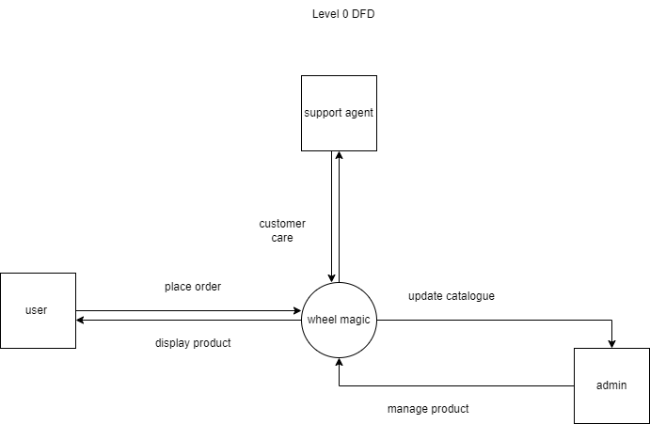

*Fig 4. 7 Level 0 DFD*

**4.4.3.2. Level 1 DFD**

The user serves as the central entity, representing the end-user of the app. The system consists of multiple modules handling different functionalities. The user management module is responsible for user registration, login, profile management, and other related tasks. The product management module oversees the product catalog, inventory, and associated information. The order management module processes orders, handles payments, and manages order statuses. The marketplace module facilitates interactions between buyers and sellers if applicable. The customer support module provides users with various support channels and services, while the review and rating module allows users to submit and view product reviews and ratings.

The system’s data flows ensure smooth interactions between modules. The user initiates various actions, such as searching for products, which retrieves product information from the product management module. Displaying products follows a similar process, where the product management module provides the relevant details. When a user adds an item to the cart, the information is sent to the order management module. Updates to order status are communicated back from the order management module to the user. The review and rating module handles product reviews submitted by users, while customer support requests are directed to the customer support module. If the marketplace module is present, users can manage their product listings through it.

The product management module provides inventory data to the order management module and updates its catalog based on user inputs. The order management module processes orders by receiving user input, confirms payments through the payment gateway, and updates the order status, notifying the user accordingly. The customer support module interacts directly with users to address their queries and issues.

External entities interact with different modules as well. The admin plays a role in managing the user and product management modules for administrative tasks. Vendors, if applicable, interact with the product management module to manage their listings. The payment gateway processes payments, ensuring secure and seamless transactions.

.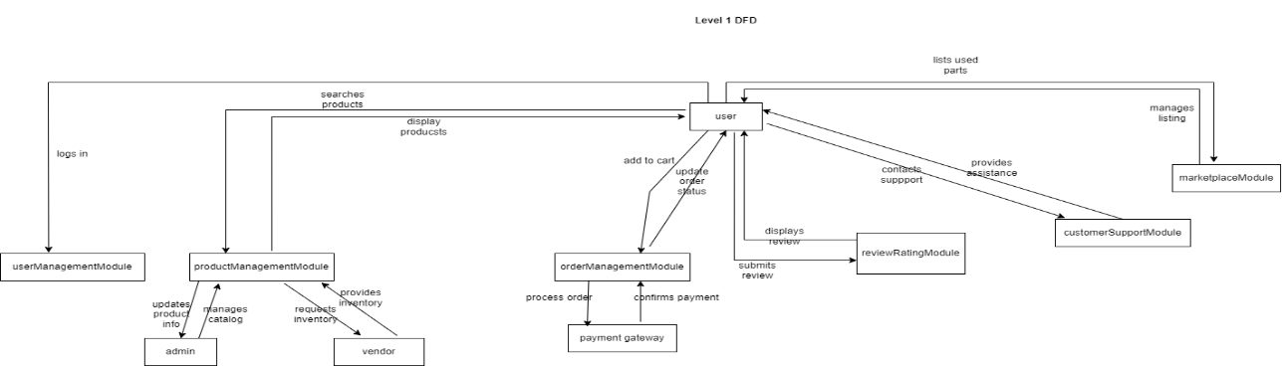

*Fig 4. 8 Level 1 DFD*

**4.4.3.3. Level 2 DFD**

The user remains the central entity, interacting with various modules that manage different functionalities within the system. The user management module includes an authentication system that handles user login and authentication, along with a user database that stores user information. The product management module consists of a product database for storing product details, while vendors interact with this module to manage their product listings. The order management module incorporates a payment gateway to process payments and an order database to store order-related information. The review and rating module includes a review database where user-submitted reviews and ratings are stored.

The customer support module provides multiple support options, including a live chat system for real-time assistance, an email support system for handling queries via email, and an FAQ database that stores frequently asked questions along with their answers. The marketplace module maintains a marketplace database that records listings and transactions if applicable.

Data flows between these modules to ensure seamless functionality. The user interacts with the authentication system to log in, the product database to search for products, and the order management module to add items to the cart. Reviews submitted by users are stored in the review and rating module, while support-related interactions are handled through the customer support module. If the marketplace feature is enabled, users manage their listings through the marketplace module.

Modules also communicate with each other. The product management module interacts with the product database to retrieve or update product information. The order management module communicates with both the order database and the payment gateway to process transactions. The customer support module accesses the FAQ database to provide relevant responses to user queries. Additionally, the marketplace module interacts with the marketplace database to store and retrieve listing and transaction details.

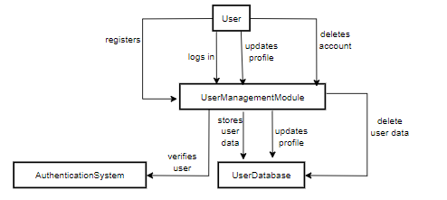

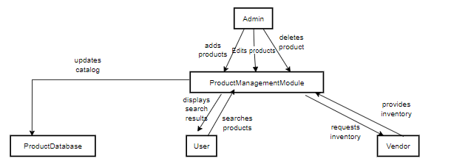

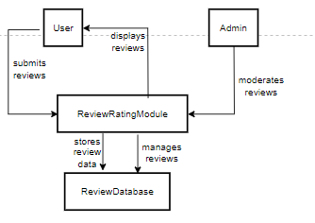

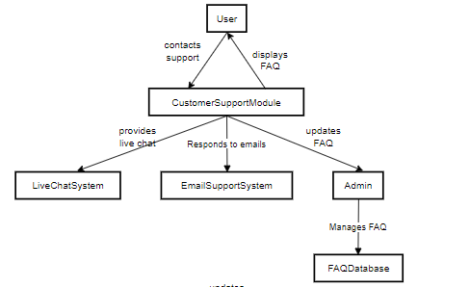

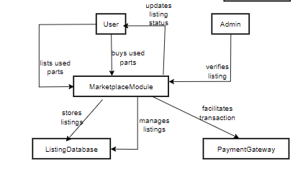

*Fig 4. 9 Level 2 DFD*

**4.4.4. Deployment Diagram**

The system consists of three main components: the client, the server, and the communication mechanisms between them. The client represents the end-users accessing the system through either a web browser or a mobile application. Web browsers allow users to interact with the system on computers and mobile devices, while the dedicated mobile app provides an optimized experience for mobile users.

The server serves as the core of the system, hosting the application logic and managing data. It includes a web server responsible for handling incoming HTTP requests from clients and an application server that processes business logic, interacts with databases, and generates responses. The database component stores persistent data such as user details, product catalogs, and order records, ensuring efficient data management.

Communication between these components happens through secure HTTPS requests, where clients send requests to the web server for various operations. The application server processes these requests and communicates with the database using SQL queries to retrieve, store, and update relevant data before sending a response back to the client. This interaction ensures a seamless and secure exchange of information within the system.

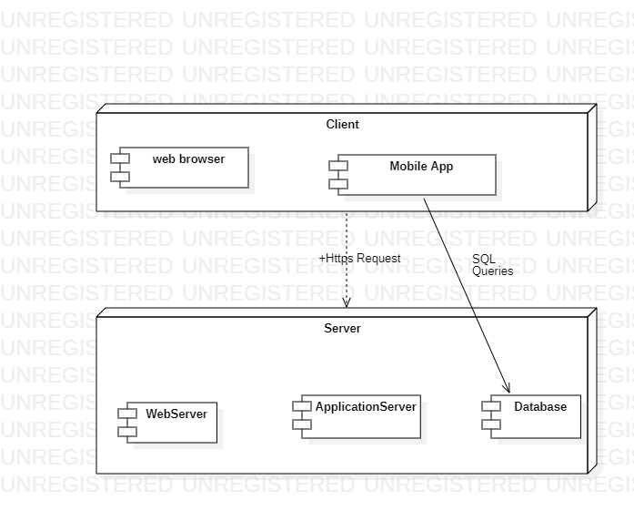

*Fig 4. 10 Deployment Diagram*

1. **Implementation**
2. 1. **Algorithm**

Algorithm for wheel magic app is given below.

* + 1. **User login and role management**

Algorithm UserLogin()

Input: Username, Password

Output: Access to Dashboard or Error Message

BEGIN

Fetch user credentials from database

IF Username and Password match database THEN

Retrieve Role

Display Dashboard Based on Role

ELSE

Display "Invalid Login"

ENDIF

END

* + 1. **Product Management**

Algorithm ManageProduct()

Input: Product Details (Name, ID, Price, Category)

Output: Product Added/Updated/Deleted

BEGIN

Display "Product Options"

CASE user selects:

Add Product:

Prompt for Product Details

Save to Database

Display "Product Added"

Update Product:

Fetch Product by ID

Prompt for Updated Details

Save Changes to Database

Display "Product Updated"

Delete Product:

Fetch Product by ID

Delete from Database

Display "Product Deleted"

ENCASE

END

* + 1. **Order placement AND payment**

Algorithm PlaceOrder()

Input: Cart Items, Payment Details

Output: Order Confirmation or Error Message

BEGIN

Display Cart Contents

Prompt User for Payment Details

IF Payment is Successful THEN

Save Order to Database

Send Notification to User

Display "Order Confirmed"

ELSE

Display "Payment Failed"

ENDIF

END

* 1. **External APIs**

APIs used:

*Table 5. 1 APIs*

|  |  |  |  |
| --- | --- | --- | --- |
| **Name of API** | **Description of API** | **Purpose of usage** | **List down the function/class name in which it is used** |
| Firebase auth | Provides authentication and user management | User login, registration, and roles | User Management Module |
| Firebase realtime DB | Cloud-hosted NoSQL database for real-time data synchronization | Storing user data, product catalog, orders | Product Management Module |
| Stripe | Secure payment processing | Processing transactions | Payment Module |
| MongoDB | for scalable and flexible data storage | Data management for reviews, feedback, and transactions | Review and Feedback Module |

* 1. **User Interface**

Details about user interface with descriptions.

* + 1. **Introduction Screen**

This section will guide you through the process of Introduction Screens on the wheel magic app.



*Fig 5. 1 Splash Screen 1*

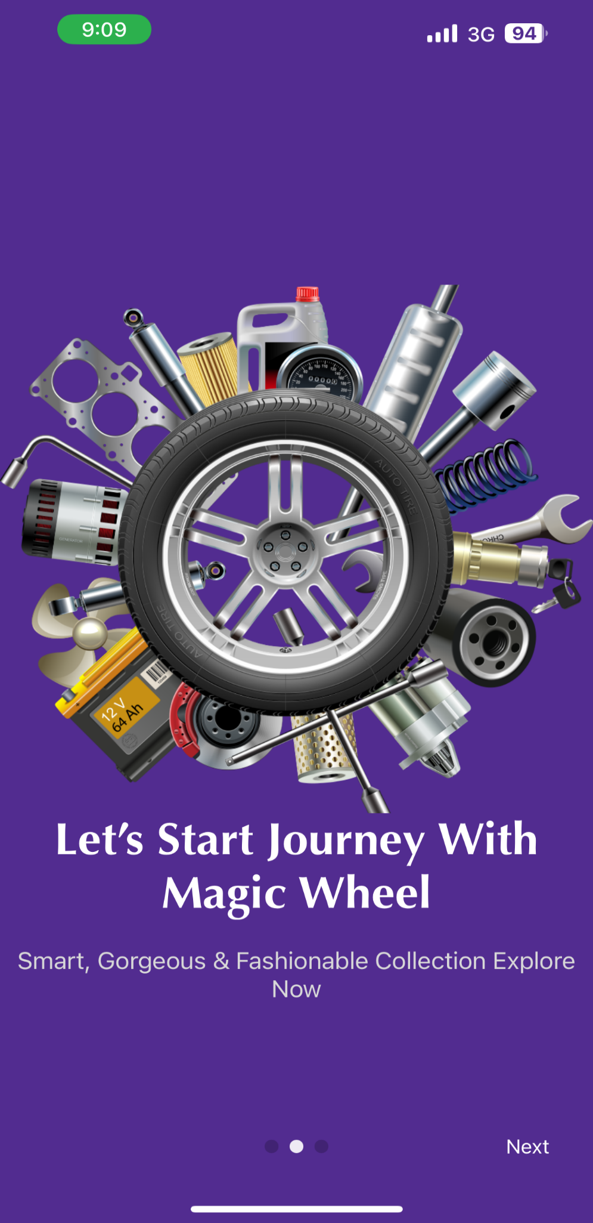

*Fig 5. 2 Splash Screen 2*

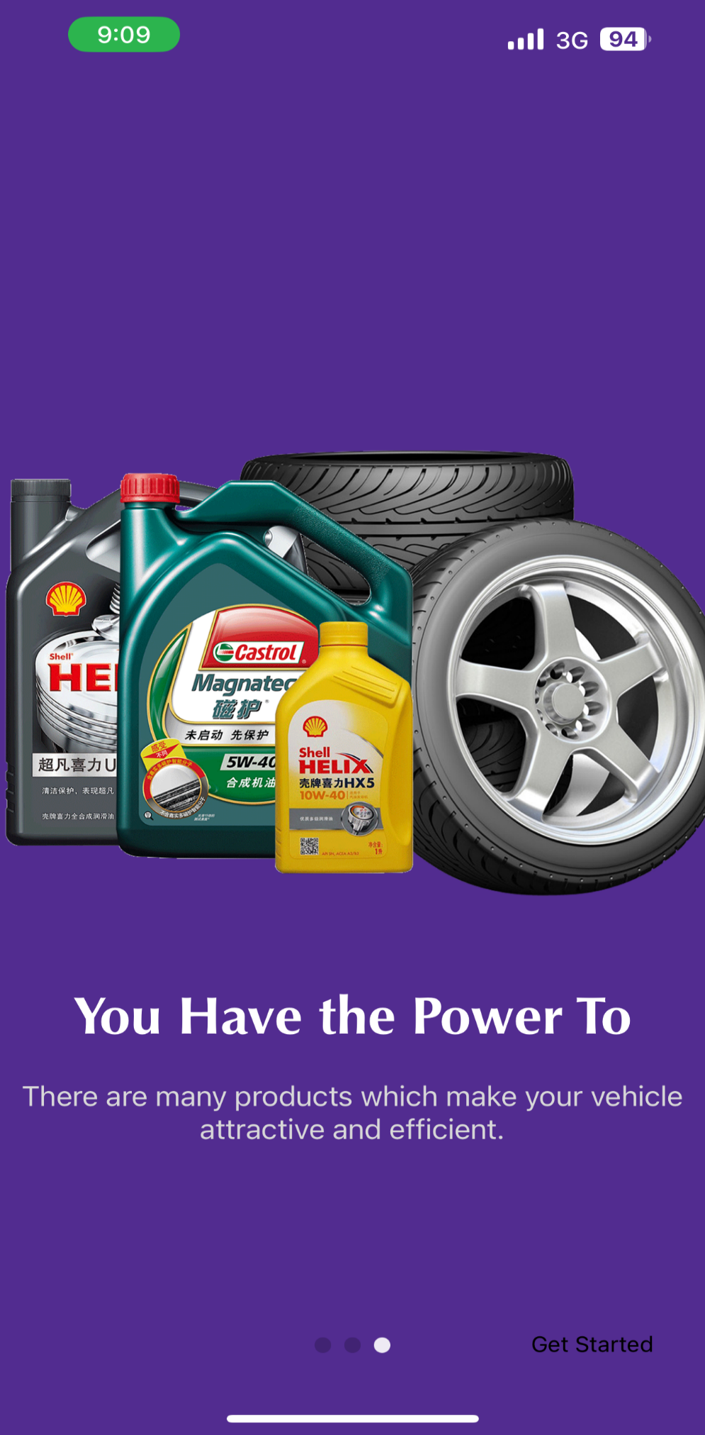

*Fig 5. 3 Splash Screen 3*

* + 1. **Signing up on wheel magic**

This section will guide you through a series of steps for creating on account on Wheel Magic.

Once you launch the Wheel Magic app, you can choose to register a new account if you don’t already have one. Tap on the "Register" button to start the registration process.

You will need to enter the following details:

Name, a valid email address, and a secure password. After entering these details, you will receive an OTP on the email address to confirm the email that you provided.

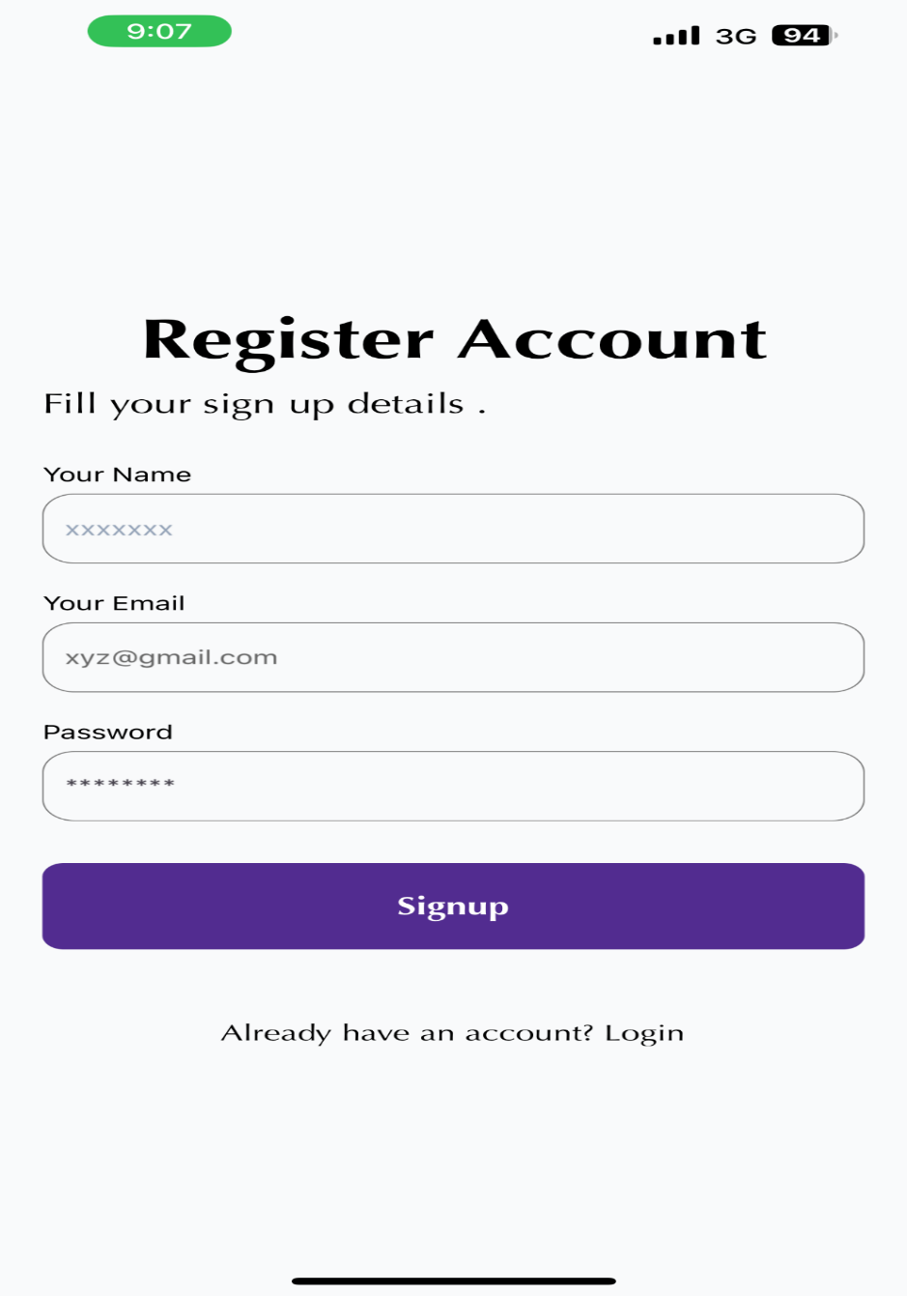

*Fig 5. 4 Register Account*

* + 1. **Notifications**

Whenever you add or remove a product to the wishlist, or when you create a listing, you will be notified.

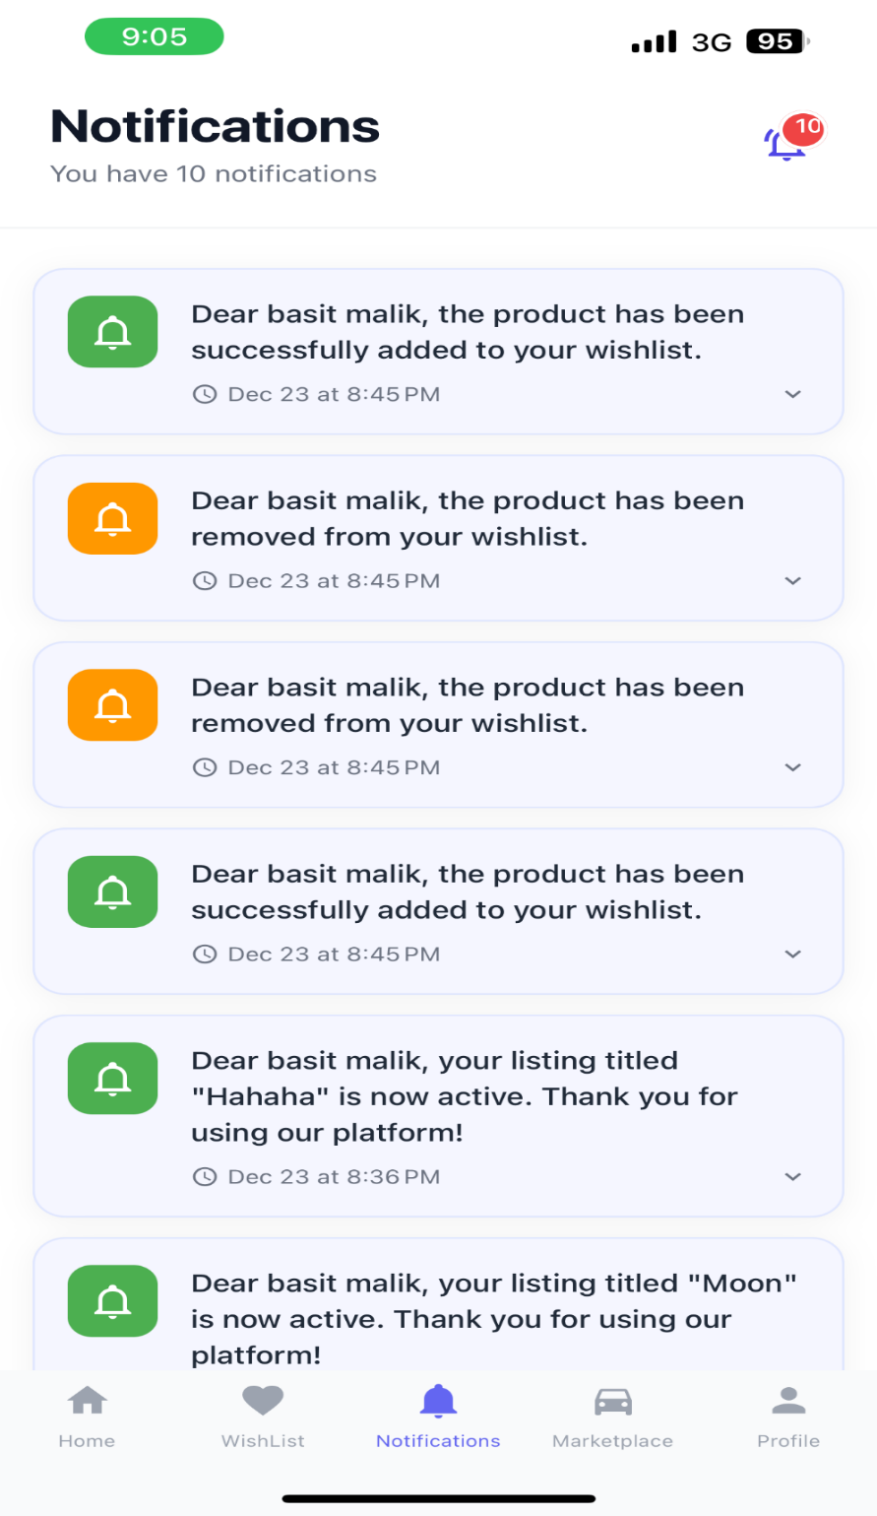

*Fig 5. 5 Notifications*

* + 1. **Wishlist**

The wishlist maintains a list of the products that you have added to the cart.

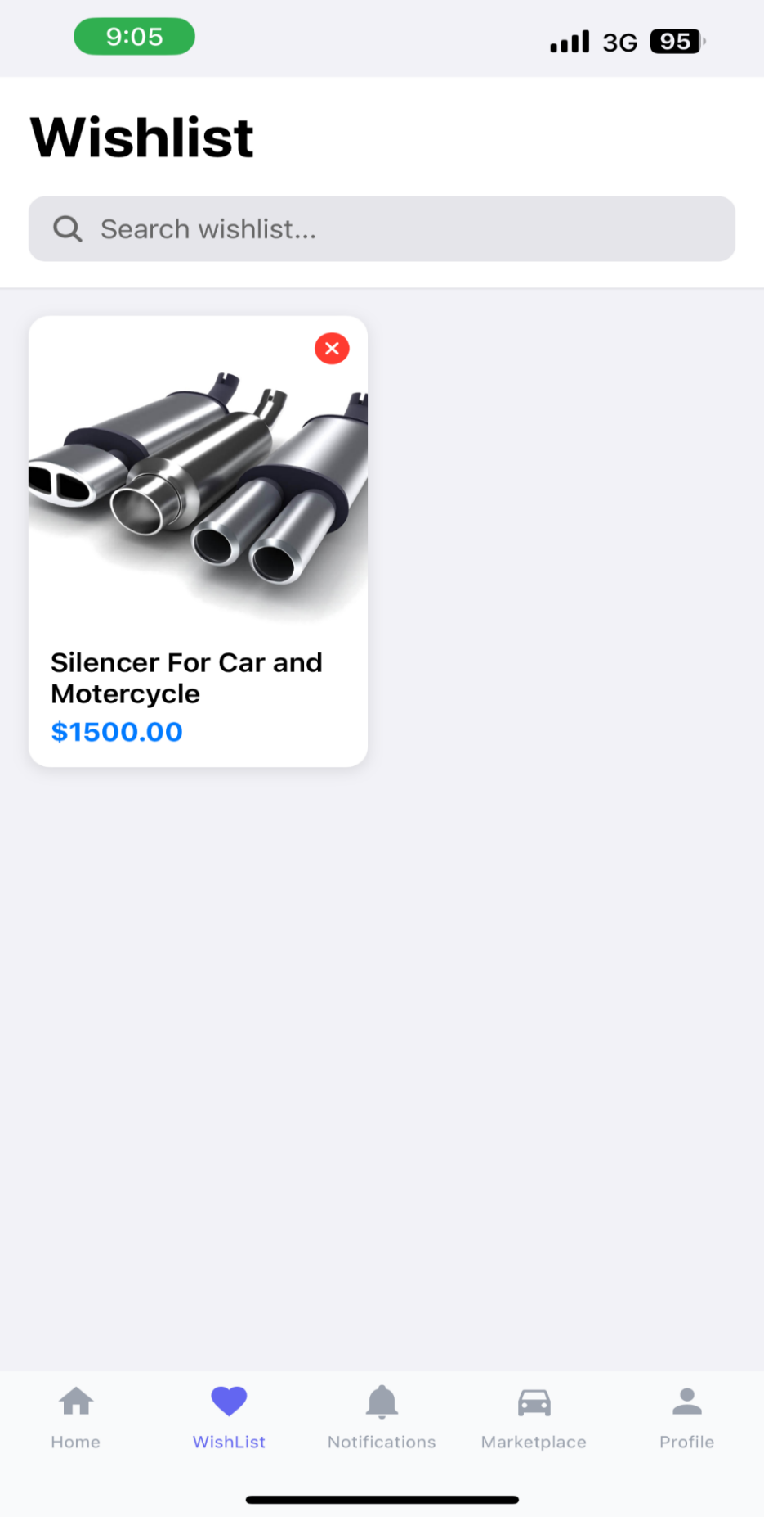

*Fig 5. 6 Wishlist*

* + 1. **Create a listing**

To create a listing, you will need to provide these details:

**Photo**: you will need to add pictures of your product, you can add up to 5 pictures.

**Name**: That is the item that you are selling.

**Description:** Describe your product.

**Price:** Give the price for your product.

**Quantity:** How many products in the stock.

**Tags:** Tags will help your product appear in the search results and popular content lists.

**Category:** The category of your product.

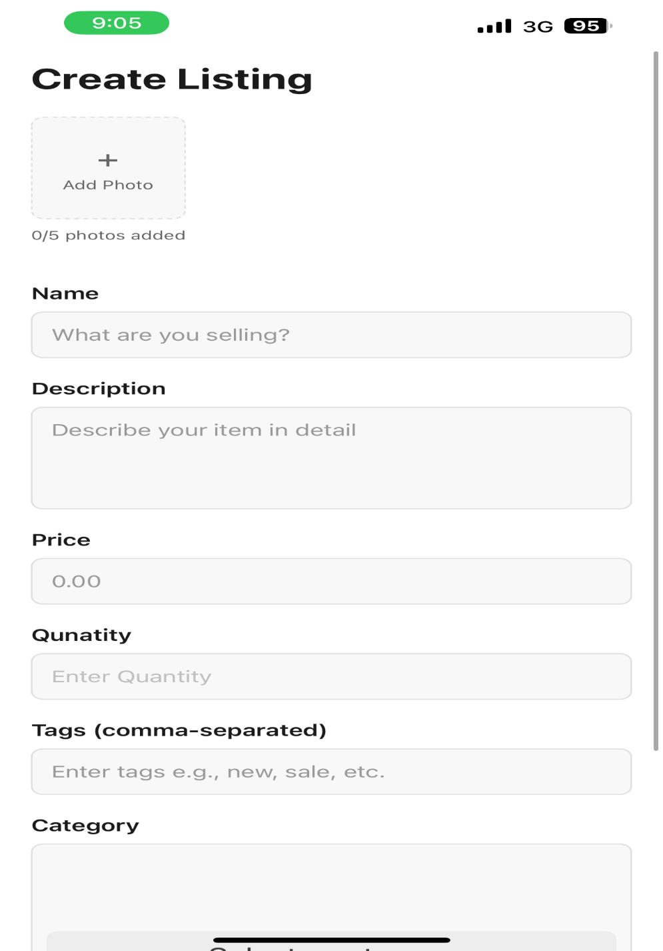

*Fig 5. 7 create listing*

* + 1. **My Listings**

This section shows the listings that you have created.

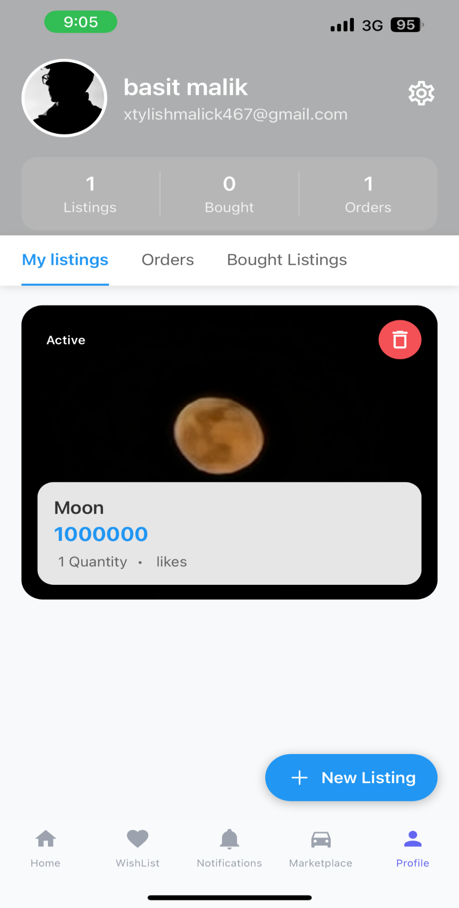

*Fig 5. 8 Listings*

* + 1. **Marketplace**

All the listings will appear here.

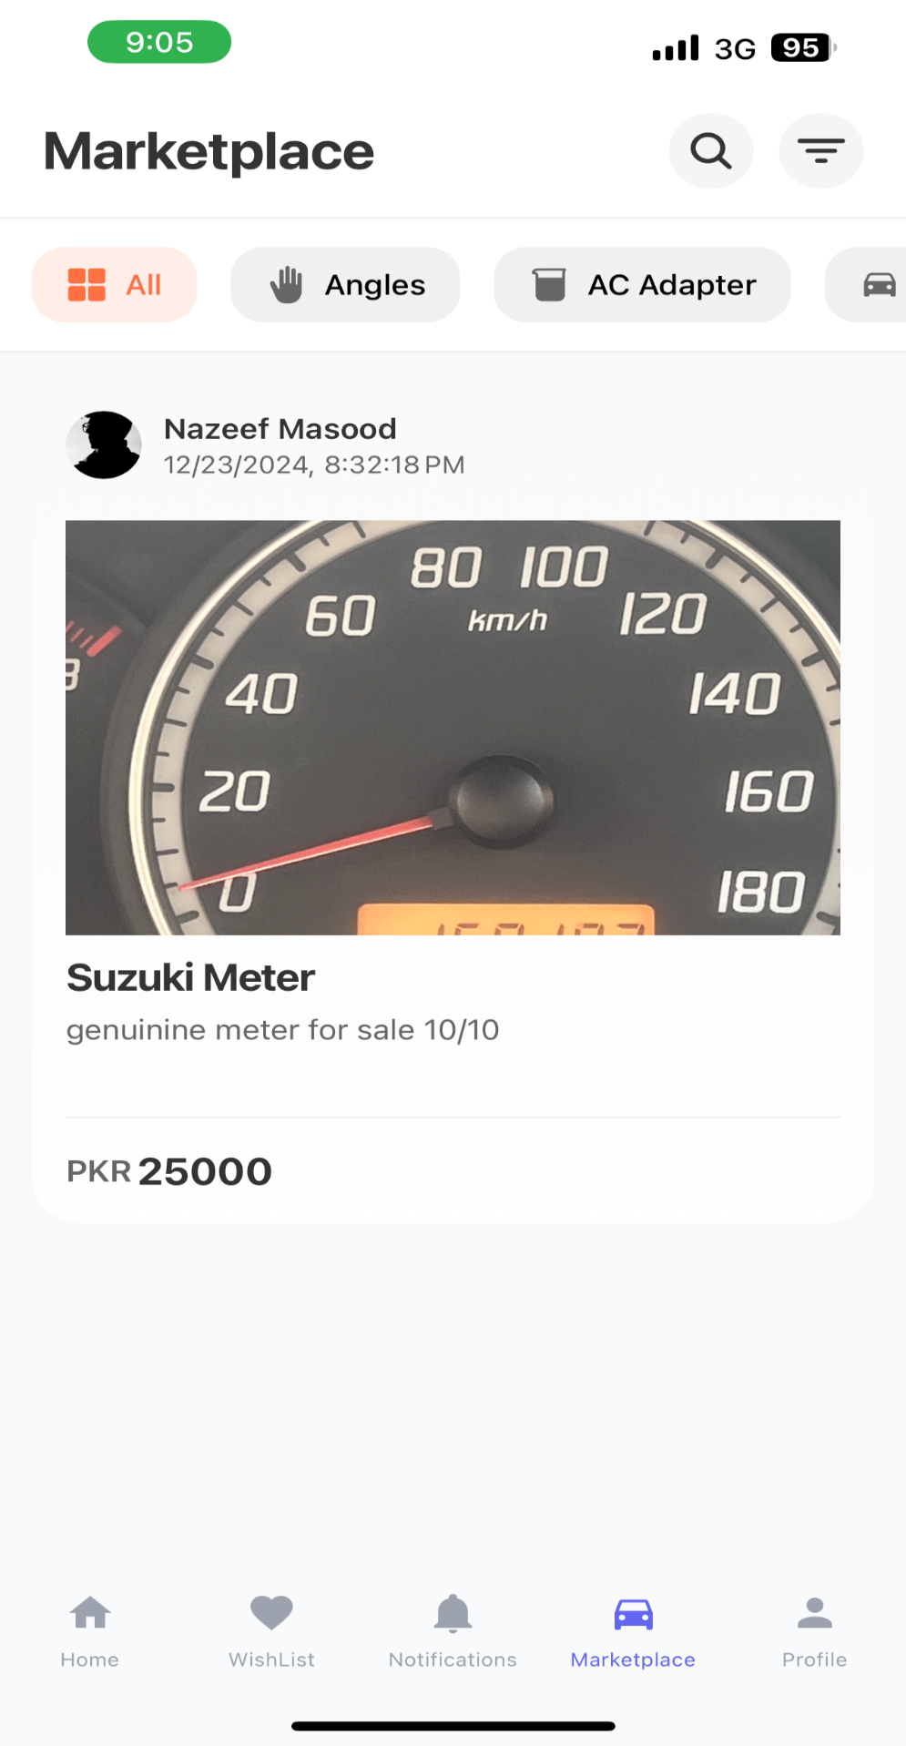

*Fig 5. 9 Marketplace*

* + 1. **Reviews**

You can check for a product’s reviews before opting for adding it to the wishlist.

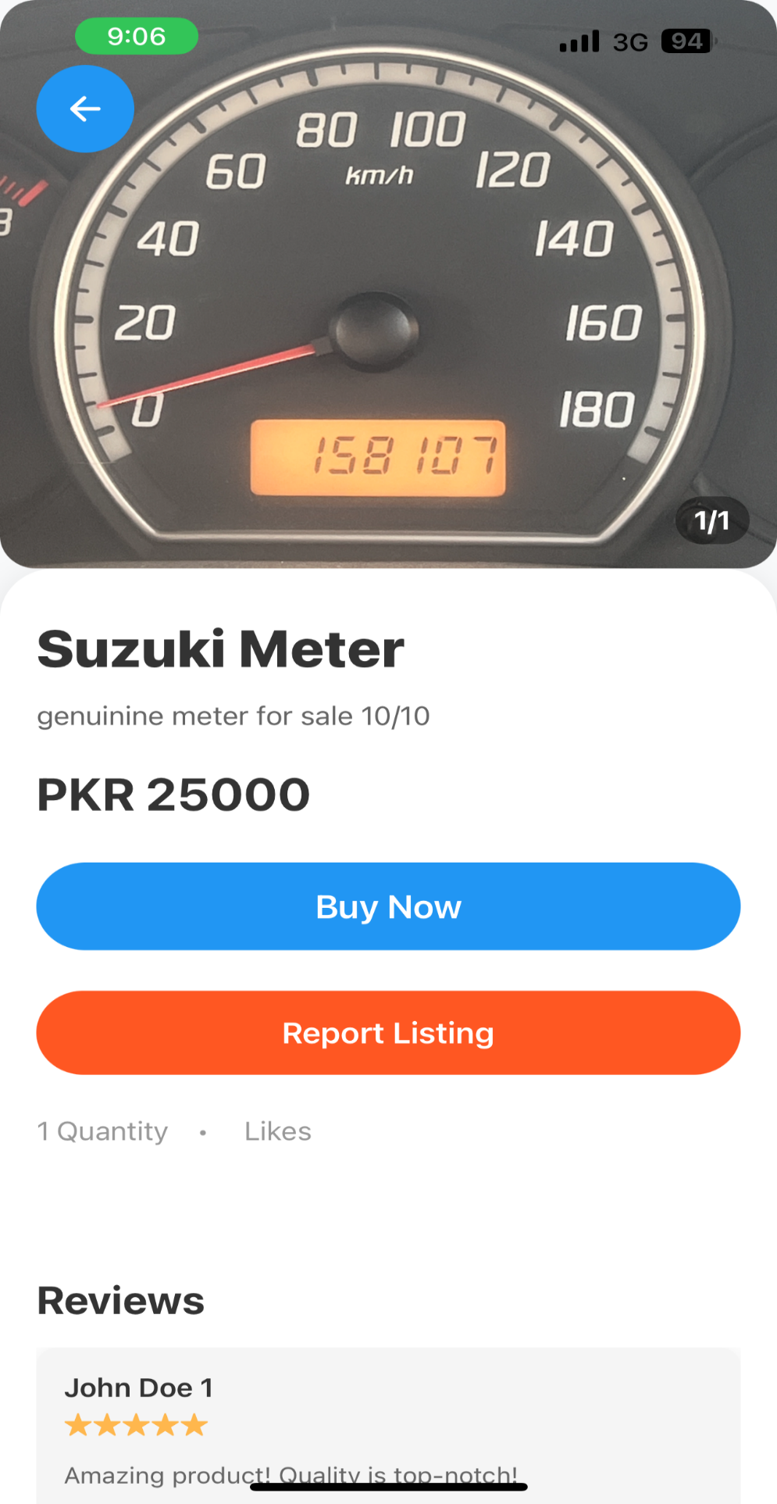

*Fig 5. 10 Reviews*

* + 1. **Checkout**

After adding a product to the wishlist, you will proceed to checkout.

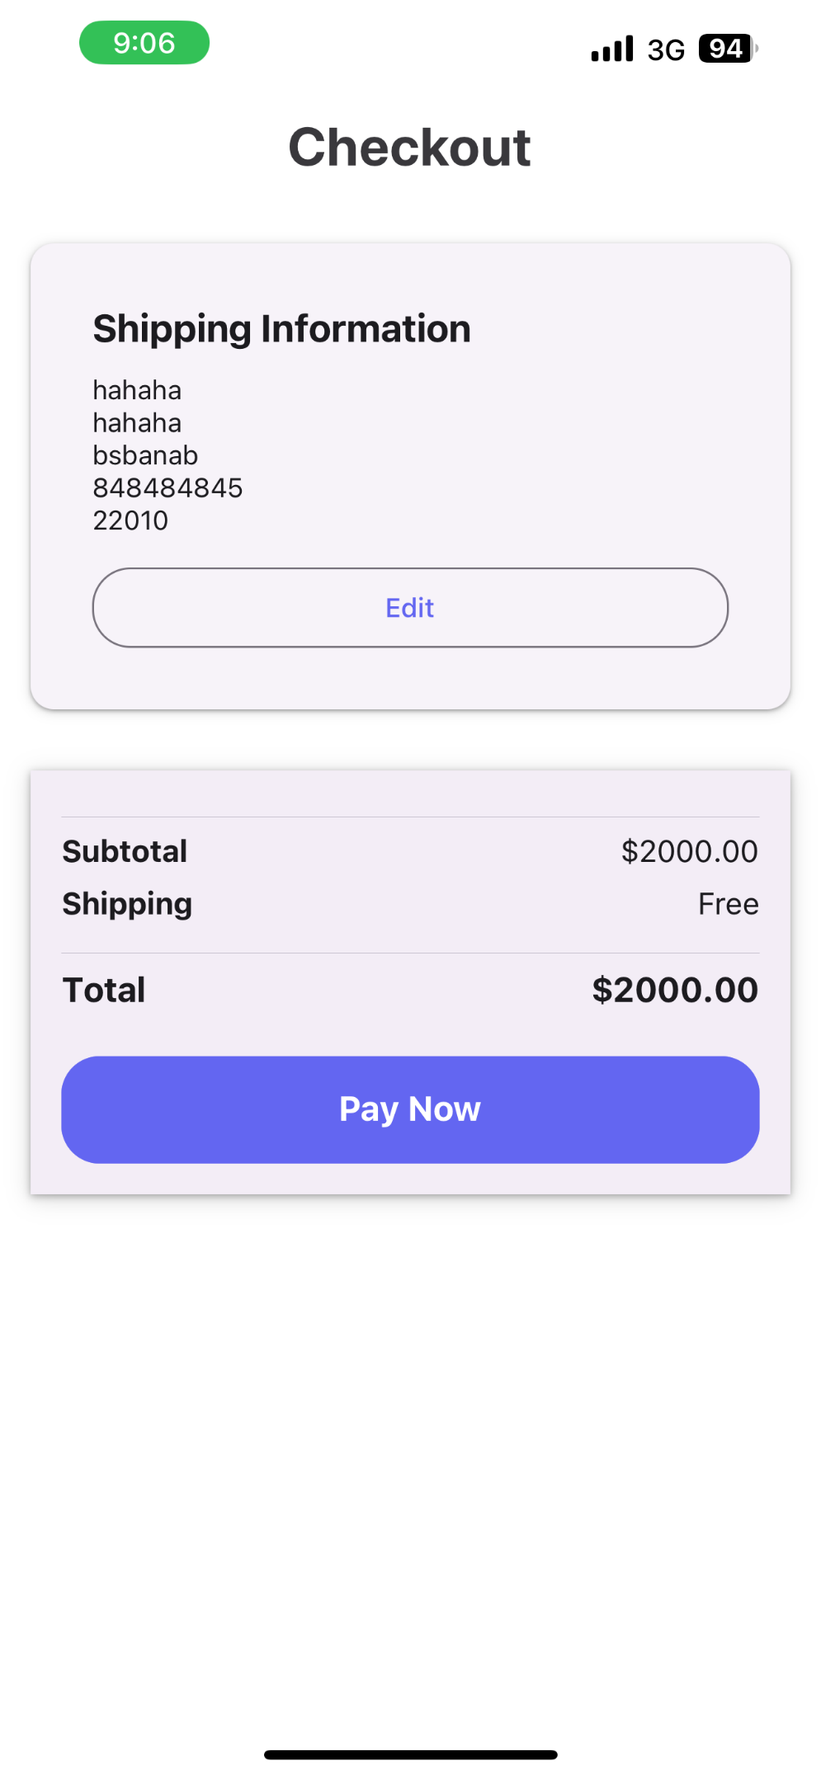

*Fig 5. 11 Checkout 1*

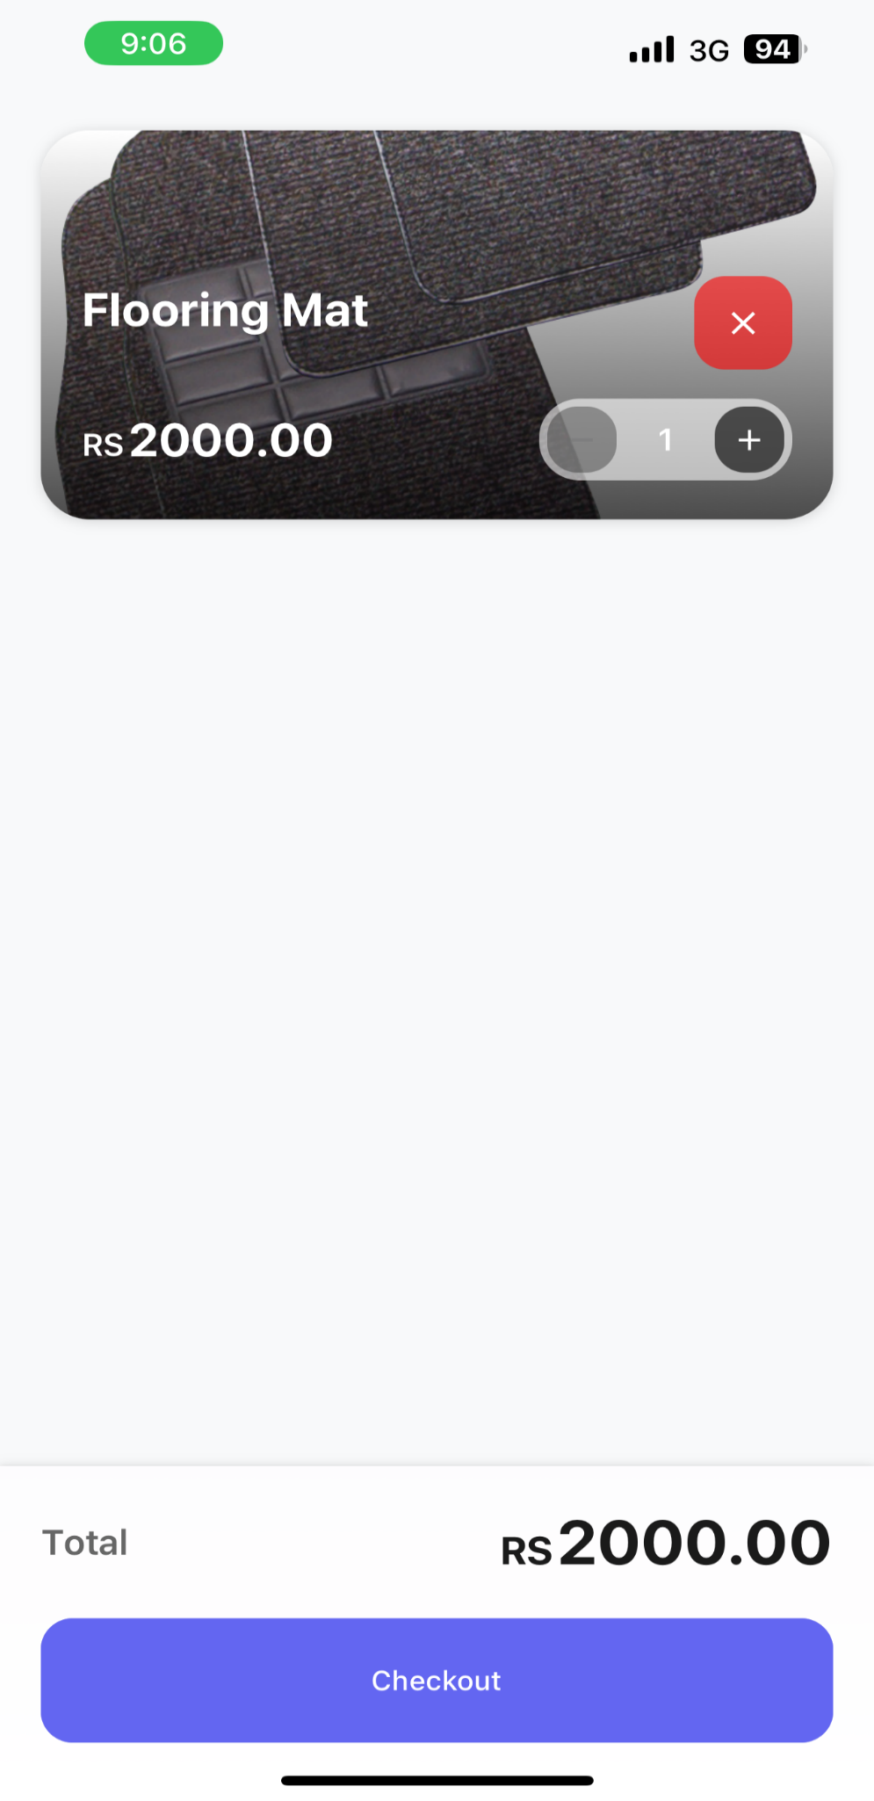

*Fig 5. 12 Checkout 2*

1. **Testing and Evaluation**

This section involves manual testing.

8. 1. **Manual Testing**

System testing, unit testing, functional testing and integration testing have been implemented.

6. 1. 1. **System testing**

|  |  |  |  |  |
| --- | --- | --- | --- | --- |
| Test case id | Test case/Test script | Attribute and value | Expected result | Result |
| 01 | Verify user workflow | Register → Login → Browse Wishlist → Place Order | All modules interact correctly, and order is placed | pass |
| 02 | Test marketplace functionality | List product → Buy product | Product is listed and purchased successfully | pass |
| 03 | Notification system | Generate notifications | Notifications are sent and received correctly | pass |

*table 6.1. 1. System Testing*

* + 1. **Unit Testing**
* **Testing Objective:** To ensure the login form is working correctly

|  |  |  |  |  |
| --- | --- | --- | --- | --- |
| **No.** | **Test case/Test script** | **Attribute and value** | **Expected result** | **Result** |
| 1. | Verify user login after click on the ‘Login’ button on login form with correct input data | Username:  mbasit467@gmail.com  Password:  1234678 | Successfully log into the main page of the system. | Pass |
| 2. | User inputs wrong password | Username: [mbasit467@gmail.com](mailto:mbasit467@gmail.com)  Password:3456 | Doesn’t login to the main page of system. | Pass |
| 3. | User clicks on forgot password. | Username: [mbasit467@gmail.com](mailto:mbasit467@gmail.com)  Password: forgot password | User is navigated to email page to input his email and after verification he is set to reset his password. | pass |
| 4. | Verify saving profile changes after editing profile fields. | Fields updated with valid data | Profile changes saved and reflected in the database. | pass |

*table 6.1. 2. Unit Testing*

* + 1. **Functional Testing**
* **Functional Testing 1:** Login with different roles as shown in Table 6.4

**Objective**: To ensure that the correct page with the correct navigation bar is loaded.

|  |  |  |  |  |
| --- | --- | --- | --- | --- |
| **No.** | **Test case/Test script** | **Attribute and value** | **Expected result** | **Result** |
| 1. | Login as ‘user’. | Username: chairmanbilal0@gmail.com  Password: 1234567 | Main page for the user is loaded. | Pass |
| 2. | Login as ‘admin’ | Username: mbasit467@gmail.com Password:12345678 | Main page for the admin will be loaded. | pass |

*table 6.1. 3 Functional Testing*

* + 1. **Integration Testing**

Table 6.1.4. shows the integration testing.

* + - 1. **Marketplace and payment system integration**

|  |  |  |  |  |
| --- | --- | --- | --- | --- |
| **No.** | **Test case/Test script** | **Attribute and value** | **Expected result** | **Result** |
| 1. | Complete a purchase for an item listed in the marketplace. | Select an item, proceed to checkout, and pay. | Payment is processed successfully, and the item is marked as "Sold" in the marketplace. | Pass |
| 2. | Attempt to purchase an item out of stock. | Select an out-of-stock item and proceed to checkout. | System displays a message: "Item is out of stock." | Pass |
| 3. | Verify marketplace stock after payment success. | Complete a payment for a product. | Stock of the purchased item decreases by 1 in the marketplace. | Pass |

*table 6.1.4. 1. Marketplace and payment system integration*

* + - 1. **Wishlist and Notifications integration**

|  |  |  |  |  |
| --- | --- | --- | --- | --- |
| **No.** | **Test case/Test script** | **Attribute and value** | **Expected result** | **result** |
| 1. | Notify users when an item in their wishlist is back in stock. | Add an out-of-stock item to the wishlist. | System sends a notification when the item becomes available in the marketplace. | pass |
| 2. | |  | | --- | |  |  |  | | --- | | Verify notification content for wishlist price drops. | | Reduce the price of an item in the marketplace. | System sends a notification showing the updated price for the wishlist item. | pass |

*table 6.1.4. 2 Wishlist and Notification System*

* + - 1. **Payment system and Order management integration**

|  |  |  |  |  |
| --- | --- | --- | --- | --- |
| **No.** | **Test case/Test script** | **Attribute and value** | **Expected result** | **Result** |
| 1. | Generate an order after successful payment. | Complete payment for an item in the cart. | System generates an order and displays order details to the user. | Pass |
| 2. | Attempt order generation with failed payment. | Simulate a failed payment. | System does not generate an order, and an error message is displayed. | Pass |
| 3. | Verify order cancellation and refund. | Cancel an order after payment. | System cancels the order, updates the marketplace stock, and initiates a refund. | Pass |

*table 6.1.4. 3 Payment system and notification system*

* + - 1. **Notification and customer live support integration**

|  |  |  |  |  |
| --- | --- | --- | --- | --- |
| **No.** | **Test case/Test script** | **Attribute and value** | **Expected result** | **result** |
| 1. | Notify users of unresolved support tickets. | Submit a support ticket and leave it unresolved. | System sends a notification reminding the user of an unresolved support ticket. | pass |
| 2. | |  | | --- | |  |  |  | | --- | | Verify real-time notification for customer support responses. | |  | |  | | Respond to a customer support ticket. | User receives a real-time notification of the response. | pass |

*table 6.1.4. 4 Notification and customer live support integration*

* + - 1. **Review and Feedback with marketplace integration**

|  |  |  |  |  |
| --- | --- | --- | --- | --- |
| **No.** | **Test case/Test script** | **Attribute and value** | **Expected result** | **result** |
| 1. | Submit feedback for a purchased item. | Complete an order and submit feedback. | Feedback is saved, and the marketplace updates the product rating. | pass |
| 2. | |  | | --- | |  |  |  | | --- | | Verify reviews are visible in the marketplace. | | View a product with reviews. | Product page displays all user-submitted reviews and ratings. | pass |

*table 6.1.4. 5 Review and feedback with marketplace integration*

1. **Conclusion and Future Work**

This chapter concludes the project and highlights future work.

1. 1. **Conclusion**

The **Wheel Magic App** successfully addresses the challenges faced by vehicle owners in finding genuine spare parts and accessories. Through features such as personalized recommendations, a user-friendly marketplace for new and used parts, secure payment gateways, and real-time notifications, the app enhances user experience and builds trust in online transactions. The project demonstrates the efficient application of modular design principles, agile methodology, and robust testing practices, making it a comprehensive solution for the automotive e-commerce market.

* 1. **Future Work**

To enhance the functionality and impact of the project, several key improvements are proposed. First, implementing AI-powered price suggestions through machine learning algorithms will allow for competitive pricing recommendations based on current market trends. This will enable sellers to better price their products while remaining competitive. Second, the introduction of an advanced analytics dashboard will provide both sellers and buyers with deeper insights into trends, purchase behaviours, and personalized recommendations, helping users make more informed decisions. Additionally, integrating with delivery services will enable real-time shipment tracking, offering customers greater transparency and convenience in managing their orders. Finally, incorporating augmented reality (AR) will allow users to visualize spare parts in 3D, ensuring compatibility with their vehicles and enhancing the overall shopping experience by helping them make more accurate purchasing choices. These enhancements will significantly improve both the functionality and user engagement of the platform.

1. **References**
2. Ali Behforooz & Frederick J. Hudson, (1996), Software Engineering Fundamentals, Oxford University Press. Chapter 8, pp. 255-235.
3. Lyda M.S. Lau, Jayne Curson, Richard Drew, Peter Dew, and Christine Leigh, (1999), Use Of VSP Resource Rooms to Support Group Work in a Learning Environment, ACM 99, pp. 2.
4. Hideyuki Nakanishi, Chikara Yoshida, Toshikazu Nishmura, and Turu Ishada, (1996), FreeWalk: Supporting Casual Meetings in a Network, pp. 308-314 (paper on web)

**PlagiarismReport** 